Visualisation Design Book

Title: Hospitalised Injuries from Road Crashes Among First Nations Peoples in Australia (2011 – 2021)

Team Name: DV14_T5
Students: Helen and Akhila
Tutorial: Tuesday 4:30 pm – 6:30pm

Tutor: Raihaneh Aghaie
Semester: 2026-H1

Table of Contents
Contents
Visualisation Design Book 1
Introduction 2
1.1 Background and Motivation 3
1.2 Visualisation Purpose 3
Data 4
2.1 Data Source and Governance 4
2.2 Data Processing and Analysis 6
2.3 Data Exploration 8
Visualisation Design 11
3.1 Website Design 11
3.2 Visualisation Design 11
3.3 Interaction Design 11
Iteration and Validation 12
4.1 Testing and refinements 12
4.2 Usability evaluation 12
Conclusion 12
Future Improvements 12
References 13
Appendices 13

Introduction
  - Background and Motivation
Target Audience
Our visualisation is made for the Australian public. It also helps university students and journalists who care about health equity and road safety. These people do not have to be experts in data. They are interested in social issues. They want to know how road crashes affect different communities in real life. Our goal is to share a clear story using data. We want everyone to understand it.

Why This Matters
Every year, many Australians go to the hospital because of road crashes. The risk is not the same for everyone. First Nations people suffer from road accidents more often than other Australians. Many reports and large government spreadsheets hide this fact. Our project shows this hidden problem. We turn complex data into a simple and interactive story. This helps people see the difference and understand why road safety needs to focus on fairness.

What Users Can Do
With our visualization, anyone from the public can learn important facts in just a few minutes.
- See the big picture: people can understand how road crash hospitalisations for First Nations peoples have changed over 11 years across Australia.
- Spot the high-risk groups: people can quickly find who is most at risk, such as young adults. And they can also see which types of road users, like pedestrians, and which places, like remote areas, face the highest risk.
- Grasp the inequality: the charts compare First Nations and non-Indigenous groups side by side. This makes it easy to see the biggest differences and shows why action is needed.

  - Visualisation Purpose

Key Questions This Visualisation Answers
Our visualisation will answer the following questions.
- Is the number of First Nations people going to the hospital because of road crashes getting better or worse in the past 10 years?
- Who faces the highest risk? For example, is it young people, pedestrians, or people living in remote areas?
- Where is the difference between First Nations and non-Indigenous Australians the largest? Does it happen in a certain age group or with a certain type of road user?

Three main areas we explore:
- Trends: How have hospitalisation numbers changed over 11 years?
- Risk profiles: Which age groups, road users, and locations face the highest burden?
- Disparities: Where is the gap between First Nations and non-Indigenous Australians the widest?

Data

2.1 Data Source and Governance
2.1.1 Data Source
The main dataset for this project is about hospitalised injuries from road crashes in Australia from 2011 to 2021. The Bureau of Infrastructure, Transport, Regional Development, Communications and the Arts (BITRE) publishes it. The data comes from the National Hospital Morbidity Database, made by the Australian Institute of Health and Welfare (AIHW).
This dataset counts how many people are hospitalised after road crashes. It pays special attention to First Nations peoples and compares them with Non-Indigenous Australians.

The main data file used in this project is:
- First-Nations-hospitalised-injuries-2023.xlsx – this file has five summary tables (for annual totals, road user, age group, remoteness, and counterparty) and a raw sheet that break down numbers every six months. We use this file for all comparisons between First Nations and non-Indigenous groups.

A supplementary data file is also referenced:

- state-and-territory-hospitalisation-injury-publication-2023.xlsx – this file breaks data down by state, year, road user, gender, age group, and counterparty. We mainly use it for background, not main analysis.
- hospitalisation_injury_publication_sep2023.xlsx – this file shows hospitalisation numbers for all Australians, but it does not break them down by Indigenous status. This dataset provides national totals for all Australians without Indigenous status breakdown. It used only for contextual reference.

The official Data Dictionary is used to understand variable definitions and data limitations:

- hospitalised-injury-data-dictionary-september-2023.pdf – defines all variables, categories, inclusion criteria, and methodological notes.

All datasets are available at BITRE’s official portal: https://www.bitre.gov.au/publications/ongoing/hospitalised-injury

2.1.2 Data Summary Table
Attribute | Description
Data Source | AIHW National Hospital Morbidity Database (via BITRE)
Primary File | First-Nations-hospitalised-injuries-2023.xlsx
Time Period | 2011-2021 (11 years)
Geographic Coverage | Australia (at the national level)
Population Groups | First Nations peoples, Non-Indigenous Australians
Key Variables | Calendar year, Indigenous status, Age group, Road user type, Remoteness category, Hospitalisation count
Tables Used | Table 1 (Annual), Table 2 (By Road User), Table 3 (By Age Group), Table 4 (By Remoteness), Raw data sheet
Number of Records | 11 rows per table (one each year), plus approximately 2500 rows in the raw data sheet with 6-monthly breakdowns
Update Frequency | Yearly (latest in September 2023)
Unit of Analysis | Number of hospitalisation cases per category per year

2.1.3 Data Governance
Data Collection Process
State and territory health departments collect the data. AIHW combines their data into a central hospital database. Each entry is for one episode of hospital care. That means it covers the whole stay, from check-in to leaving the hospital.
They use a code system called ICD-10-AM to label cases. Only cases caused by road traffic crashes are included. The dataset leaves out special cases, like newborn care or hospital boarders, and focuses only on standard care.
BITRE publishes tables from this database. The tables are grouped by year, Indigenous status, age, road user type, remoteness, and counterparty.

Data Quality Assessment
The dataset is official and reliable for public health use, but there are a few issues:
- Suppressed values (“n.p.”): Sometimes, small counts (less than 5) are not shown to protect privacy. This happens for small categories and very small regions. We show these as missing instead of filling them in.
- Data breaks: In 2012, Victoria changed how it counts cases. In 2017, New South Wales did something similar. Both changes affect how numbers compare over time, but since we report national trends, the impact is limited. NISU estimated this decreased admitted case counts in Australia by approximately 5.6% in 2012-13 compared to 2011-12.
- Counts, not rates: The data only gives the number of hospitalisations, not rates per person. We cannot show hospitalisation rates for different groups, so differences in size between groups may affect the results.
- Fixed categories: The tables only show the groupings made by the source, we cannot split them further.

Security, Privacy, and Ethics
- The dataset is already fully de-identified and only contains group totals. There is no personal information. The “n.p.” rule helps protect privacy for small First Nations communities.
- When we show First Nations data, our project tries to highlight system problems, not blame people. We follow ethical rules for reporting Indigenous health.
- Data files are kept secure on our computers and private GitHub. All files are safe and not shared with the public.
- The dataset is free for education and non-commercial projects.

2.1.4 How the Data Supports Our Key Questions
We use different tables from our dataset to answer each project question.
Core Question | Supporting Data | How it helps
Has the number of First Nations people hospitalised changed over 10 years? | Table 1 – Annual numbers | Lets us see yearly numbers for First Nations and non-Indigenous Australians from 2011 to 2021.
Who is at highest risk? Which age, road user, place? | Tables 2-4 | Each table breaks down the numbers for First Nations people, showing where risk is highest.
Where is the biggest gap between groups? | Tables 1-4 | Every table gives numbers for both groups, so we can easily compare side by side.

Using these tables helps us make charts that directly answer our main questions.

2.2 Data Processing and Analysis
2.2.1 Key Attributes and Data Types
Our cleaned dataset includes several key attributes taken from the First Nations hospitalised injuries file. These attributes are:
Attribute | Description | Data Type
Calendar Year | Year of hospitalisation (2011-2021) | Ordinal
Indigenous Status | “First Nations peoples” or “Non-Indigenous Australians” | Categorical (Nominal)
Age Group | 0-7, 8-16, 17-25,26-39, 40-64, 65+ | Categorical (Ordinal)
Road User Type | Car occupant, Motorcyclist, Pedal cyclist, Pedestrian, Heavy transport, Pick-up truck/van, Bus, Other/Unknown | Categorical (Nominal)
Remoteness Category | Major Cities, Regional, Remote | Categorical (Ordinal)
Hospitalisations | Number of hospitalised injury cases | Ratio (Quantitative)

We also used a state-and-territory dataset during early exploration. Its attributes are:
Attribute | Description | Data Type
Calendar Year | Year of hospitalisation (2011-2021) | Ordinal
State/Territory | NSW, VIC, OLD, SA, WA, TAS, NT, ACT | Categorical (Nominal)
Hospitalisations | Number of hospitalised injury cases | Ratio

2.2.2 Data Cleaning Process
We processed all data in the KNIME Analytics Platform. Our workflow followed a simple sequence of steps that turned the raw Excel files into clean tables ready for analysis.
Step 1: Importing the Data
- We used the Excel Reader node to load each file.
- For the state-and-territory dataset, we selected Table 1.
- For the First Nations dataset, we loaded Tables 1-4 and the raw sheet.
Step 2: Removing Unnecessary Rows and Columns
- The imported files included metadata, footnotes, blank rows, and KNIME-generated Row ID columns.
- We removed these with Row Filter and Column Filter nodes.
- This left only the columns that contained real data.
Step 3: Renaming Columns
- Some column names included footnote markers such as “NSW(a)” or Vic (b)”.
- These markers were not needed for analysis.
- We used the Column Renamer node to shorten them to simple names like “NSW” and “VIC”.
Step 4: Converting Data Types
- KNIME reads all Excel values as strings.
- Hospitalisation counts must be numeric.
- We used the Column Auto Cast node to convert these columns to integers.
- We checked each conversion to make sure it was correct.
Step 5: Reshaping from Wide to Long Format
- The original tables used a wide format.
- This format does not work well for D3.js visualisation.
- We used the Unpivot node to reshape the data into long format.
- For the state-territory dataset, the eight state columns became two columns:
“State” and “Hospitalisations”
The final table contained Year, State, and Hospitalisations.
- For the First Nations dataset, each row became a single observation with Year, Indigenous Status, Category (such as Age Group or Road User Type), and Hospitalisations.
Step 6: Aggregating Data
- We used the GroupBy node to sum hospitalisations across states for each year.
- This gave us national totals.
- We also created summaries for age groups, road user types, and remoteness categories for First Nations peoples.

Handling Missing Values
Some cells in the original files contained “n.p.”. This means the value is between 1 and 4 but is hidden for privacy. KNIME reads these as empty cells. We treated them as missing values and removed them from calculations. We did not replace them with 0.

Removing Duplicates
The dataset is already aggregated by the government. Each row represents one year and one category. We checked for duplicates and found none.

Derived Variables
We did not create new variables such as population-adjusted rates. The dataset only includes raw counts. Rate calculations would require population data from the ABS, which is outside our scope. We focused on trends, proportions, and comparisons within the available data.

2.2.3 KNIMW Workflow
We built the full workflow in KNIME. A screenshot of the workflow is shown below.
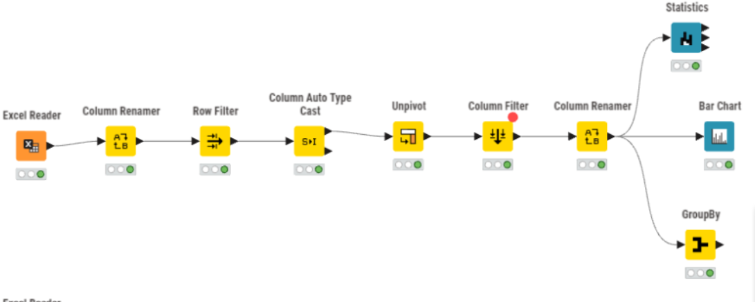

2.3 Data Exploration
After cleaning the data, we explored it to understand the main patterns. We wanted to see which groups carry the highest burden and whether any unusual trends appear. We used KNIME’s Statistics and Bar Chart nodes, along with direct checks of the First Nations dataset.

2.3.1 Summary Statistics
We calculated summary statistics from Table 1 for both population groups across the 11-year period. The results are shown below.
Statistic | First Nations peoples | Non-Indigenous Australians
Total (2011-2021) | 18,169 | 390,115
Mean per year | 1,693 | 35,465
Minimum year | 1,167 (2011) | 31,790 (2012)
Maximum year | 2,290 (2020) | 37, 482 (2019)
Change (2011-2021) | +1,053 (+90.2%) | +4, 758 (+14.9%)

The statistics show a clear difference in growth between the two groups. Both groups saw an increase in hospitalisations, but the number for First Nations peoples almost doubled. The increase for non-Indigenous Australians was much smaller.
We must interpret these numbers carefully. The dataset only reports absolute counts. It does not include population-adjusted rates. Some of the increase may come from population growth or changes in how hospitals record Indigenous status. We cannot separate these factors with this dataset.

2.3.2 National Trend Visualisation
We created a bar chart in KNIME showing total hospitalisations per year for First Nation peoples. The chart shows a steady rise from 2011 to 2018. It also shows a clear spike in 2020, followed by a small drop in 2021.
The 2020 peak may related to changes in travel patterns during the COVID-19 pandemic. We cannot confirm this with the available data.
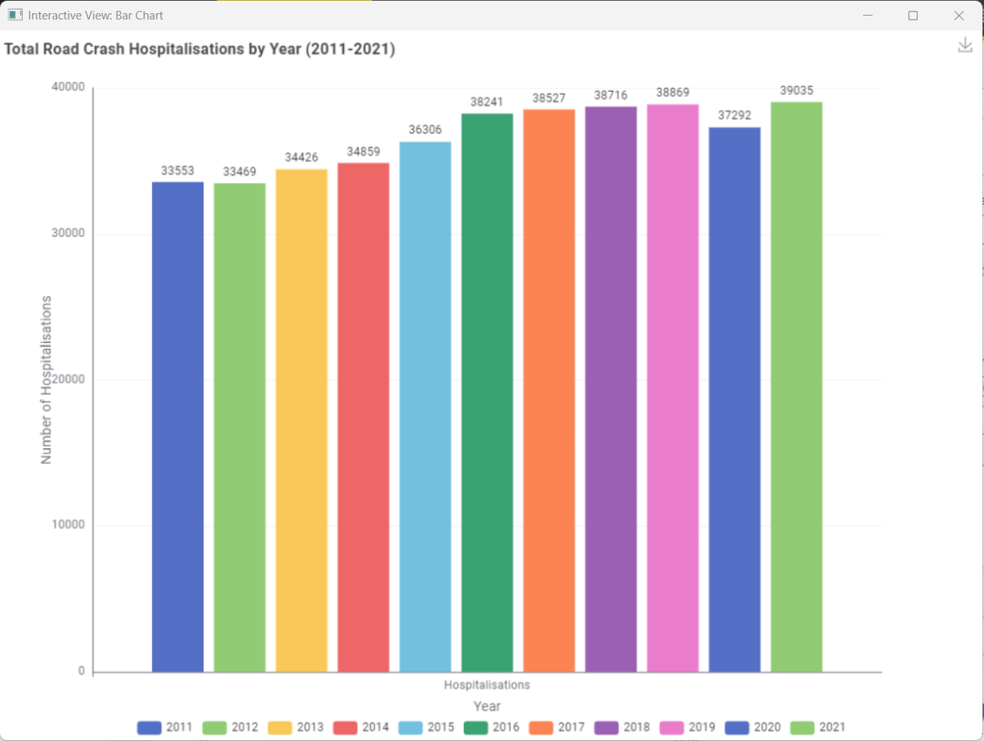

2.3.3 Breakdown by Key Dimensions
We examined the 2021 data from Tables 2, 3, and 4. We used 2021 because it is the most recent complete year.
By Age Group (Table 3, 2021)
Age Group | First Nations peoples | Non-Indigenous Australians
0-7 | 86 | 610
8-16 | 291 | 2,533
17-25 | 686 | 7,225
26-39 | 597 | 8,689
40-64 | 515 | 12,337
65+ | 45 | 5,361

Key observations:
- The 17-25 age group has the highest count for First Nations peoples.
- The 40-64 age group has the highest count for non-Indigenous Australians.
- The age patterns differ between the two groups. First Nations peoples peak in young adulthood. Non-Indigenous Australians peak in middle age.

By Road User Type (Table 2, 2021)
Road User Type | First Nations peoples | Non-Indigenous Australians
Car occupant | 1,158 | 17,098
Motorcyclist | 520 | 8,259
Pedestrian | 235 | 2,072
Pedal cyclist | 207 | 7,861

Key observations:
- Car occupants form the largest group for both populations.
- Pedestrians make up a higher share of cases among First Nations peoples.
- Pedal cyclist numbers are much lower for First Nations peoples, which may reflect different transport patterns.

By Remoteness (Table 4, 2021)
Remoteness | First Nations peoples | Non-Indigenous Australians
Major Cities | 795 | 25,254
Regional | 885 | 10,332
Remote | 503 | 600

Key observations:
- Regional areas have the highest count for First Nations peoples.
- Remote areas also show a large number, even though the Remote population is much smaller.
- The Remote figure for First Nations peoples is close to the Remote figure for non-Indigenous Australians, which suggests a higher per-person risk in remote communities.

2.3.4 Challenges Encountered During Exploration
We faced several challenges during the exploration stage.
- “n.p.” values limit detail: Many small categories show “n.p.” entries. These hide values between 1 and 4. We cannot show full breakdowns for all road user types.
- Data breaks affect comparisons: Victoria changed its case criteria in 2012, and NSW did the same in 2017. This affects state-level trends.
- Absolute counts limit comparisons: We cannot calculate rates without population data. We must be careful when comparing groups of different sizes.
- Multiple tables require separate processing: The First Nations dataset include four tables with different structures. Each table needs its own processing steps before we combine them for visualisation.

Visualisation Design
3.1 Website Design
Navigation Structure
The website will follow a single-page scrolling layout with a fixed navigation bar at the top. The navigation bar will contain four sections: Introduction, Trends, Breakdown, and About. Clicking each link will smoothly scroll the user to the relevant section of the page. This structure keeps the experience simple and linear, guiding users through a data story rather than presenting an open dashboard.
Wireframe Layout
The page will be structured top to bottom as follows:
Navigation Bar- Fixed at the top. Contains the project title on the left and the four navigation links on the right.
Hero / Introduction Section- A full-width panel with a short background paragraph and three key statistic callouts (approximately 45,000 hospitalisations per year nationally; First Nations peoples hospitalised at approximately three times the rate of non-Indigenous Australians). This section sets context before the user sees any charts.
Section 1: Trends Over Time- A line chart spanning the full content width, showing hospitalisation counts from 2011 to 2021. Filter controls (Indigenous status toggle, road user type checkboxes) sit above the chart. A short explanatory paragraph sits below.
Section 2: Breakdown by Group- Two charts side by side: a grouped bar chart on the left showing hospitalisations by age group, and a horizontal bar chart on the right showing hospitalisations by remoteness category. A short paragraph below contextualises the findings.
Section 3: Road User Types- A proportional stacked bar chart showing the share of hospitalisations by road user type (car occupants, motorcyclists, pedestrians, other) for a selected year. A year slider above the chart allows users to move through time.
Footer- Data source credit (BITRE), team name, and unit code.
Storyboard
The intended user journey through the visualisation is as follows:
- The user arrives at the page and reads the introduction. Key statistics immediately communicate the scale and significance of the issue.
- The user scrolls to the Trends section and sees the default line chart showing hospitalisation counts for both First Nations and non-Indigenous Australians over 11 years. A visible gap between the two lines is immediately apparent.
- The user toggles the Indigenous status filter to isolate First Nations peoples only, then selects a specific road user type from the checkboxes. The chart updates to show just that subset.
- The user scrolls to the Breakdown section and sees that the 17–25 age group has the highest count among First Nations peoples. They hover over that bar and a tooltip appears showing the exact count.
- The user notices that Regional areas have higher counts than Remote areas and reads the annotation noting that raw counts are not normalised for population size.
- The user moves to the Road User Types section and drags the year slider to 2021, seeing that car occupants make up over half of all hospitalisations for First Nations peoples in that year.
- The user reaches the footer and notes the data source for further reference.

3.2 Visualisation Design
Chart Types and Justification
Line Chart: Hospitalisation Trends Over Time (2011–2021) A line chart is the most appropriate choice for showing change over time. It allows users to compare First Nations and non-Indigenous groups across all 11 years using two lines, where the gap between them directly communicates disparity. Lines naturally suggest continuity and trajectory, which suits trend data.
Grouped Bar Chart: Hospitalisations by Age Group Age group is an ordinal categorical variable, not a continuous one, so grouped bars are more appropriate than a line chart. They allow direct side-by-side comparison between First Nations and non-Indigenous counts within each age category.
Horizontal Bar Chart: Hospitalisations by Remoteness The remoteness category labels are long and read more clearly on a horizontal axis. This chart type is simple and avoids misinterpretation for a general audience.
Proportional Stacked Bar Chart: Road User Types Over Time A stacked bar shows both total count and relative share of each road user type simultaneously. A pie chart was rejected because slices are harder to compare across multiple time points.
Good Design Principles
Graphical Integrity: All axes start at zero. A visible note on each chart states that counts are not normalised for population size, since jurisdictions like the Northern Territory are much smaller than Victoria and direct count comparisons can otherwise be misleading.
Accessibility: The palette uses navy blue and amber rather than red/green, making it distinguishable for colourblind users. Body text is minimum 14pt, chart labels minimum 12pt, and contrast ratios meet WCAG AA standards.
Scalability: Charts are built with responsive SVG viewBox attributes, so they rescale across screen sizes. The two-column layout stacks vertically on mobile and will be tested at 375px, 390px, and 1280px widths.
Graphical Elements, Colour, and Layout
Colour encodes group membership consistently across all charts- navy (#1B3A5C) for First Nations peoples and amber (#E8973A) for non-Indigenous Australians. Users learn this encoding once and it applies everywhere. Supporting colours are teal (#1B7F8E) for secondary series, slate (#4A6475) for grid lines, and ice blue (#D6EEF2) for background panels.
Chart titles are left-aligned above each chart. Axis labels are concise and always include units. Legends appear directly beside or below the chart they describe.
Annotations and Tooltips
Hover tooltips on all charts display the group name, year, and exact hospitalisation count on demand, avoiding permanent label clutter. Static annotations are used sparingly, one or two per chart, marking the most significant data points, such as the year with the widest gap between groups on the line chart, and the 17–25 peak bar on the age group chart.

3.3 Interaction Design
Interactive Features
Filtering: The primary interaction. Users can filter by Indigenous status (toggle between All, First Nations only, or non-indigenous only), by road user type (checkboxes for car occupants, motorcyclists, pedestrians, and other), and by remoteness category (toggle buttons for Major Cities, Regional, and Remote). Filters update all relevant charts on the page simultaneously, so the user always sees a consistent view across sections.
Year Range Slider: In the Road User Types section, a draggable slider allows users to select a specific year between 2011 and 2021. The chart updates to show the composition for that year, letting users explore how the road user mix has shifted over time.
Hover Tooltips: Available on all charts. Show exact values on demand without permanently cluttering the visual with labels.
Click to Highlight: On the line chart, clicking a line highlights it and fades the other line to reduced opacity. Clicking again restores both. This helps users focus on one group at a time.
Smooth Transitions: When filters are applied or the slider is moved, chart elements animate with a 300ms ease transition in D3 rather than snapping instantly. This helps users perceive what has changed between states
# | Interaction | Method | Element | Expected User Action | System Response
1 | Filter by Indigenous status | Toggle button | Line chart, bar charts | User clicks “First Nations only” | Charts redraw showing only First Nations Data
2 | Filter by road user type | Checkbox | Line chart | User checks or unchecks a road user type | Selected series shown or hidden on chart
3 | Filter by remoteness | Toggle button | Remoteness bar chart | User selects a remoteness category | Chart highlights selected bar, others dim
4 | View exact value | Hover | All charts | User hovers over a data point or bar | Tooltip appears with group name, year, and count
5 | Focus on one group | Click | Line chart | User clicks a line | Clicked line stays highlighted, other fades
6 | Explore road user mix by year | Drag | Year slider | User drags slider to a year | Stacked chart updates to show that year
7 | Navigate to section | Click | Navigation bar | User clicks a nav link | Page smoothly scrolls to that section

Iteration and Validation

4.1 Testing and refinements
[This section will be completed after we conduct usability testing in Week 11-12]
We plan to test the visualisation with 3-5 participants from our target audience. These include university students and members of the public.
Each participant will complete three tasks:
- Find the year with the highest number of hospitalisations for First Nations peoples.
- Identify the age group with the biggest gap between First Nations and non-Indigenous Australians.
- Describe the overall trend across the 11 years.
We will observe how each participant uses the website. We will record where they struggle and where they succeed. We will then make changes based on their feedback.

4.2 Usability evaluation
[This section will be completed after usability testing]
We will conduct a short usability evaluation with 3-5 users matching our target audience (public, students, etc.).
Task will include:
- Identify the trend of First Nations hospitalisations over time.
- Find the highest-risk age group and road user type.
- Compare disparities between First Nations and non-Indigenous groups.
We will record:
- Success rate
- Time to complete tasks
- Confusion or difficulty
- Feedback on clarity and design

Conclusion
[This section will be completed after the Visualisation is finished]
This section will describe how the project aimed to make First Nations road crash hospitalisation data easier for the public to understand. It will also outline the main insights from the 11-year trend and the differences between First Nations and non-Indigenous Australians.

Future Improvements

If we had more time, we would consider several improvements:
- Add population-adjusted rates
We could use ABS population data to calculate rates per 100, 000 people. This would allow fairer comparisons between groups.
- Include state-level breakdowns
This would let users explore geographic differences, not just national trends.
- Add more interactivity
Features like animated year-by-year transitions or filters for remoteness could help users explore the data more deeply.
- Improve accessibility
We could add keyboard navigation and screen reader support to make the visualisation more inclusive.

References
References consulted (blogs, books, academic papers, discussion/help forums - for both design and programming)

Appendices
Gen AI Declaration

Usability evaluation test materials (if used)

Notes/data collected in usability evaluation (if used)

